**How To Create A Virtual Machine Using Azure CLI**

Well, You can also quickly able to create a VM using[**Azure CLI**](https://azurelessons.com/install-azure-cli-on-windows/). Use the below steps to create a virtual machine using Azure CLI.

**Step-1:** Create a **resource group** using the below command in Azure CLI.

az group create --name myRsgGroup --location eastus

Once you will execute the above command, you will get the output like below

{

"id": "/subscriptions/1cdf4300-dee5-4518-9c9c-feaa72a5cbd1/resourceGroups/myRsgGroup",

"location": "eastus",

"managedBy": null,

"name": "myRsgGroup",

"properties": {

"provisioningState": "Succeeded"

},

"tags": null,

"type": "Microsoft.Resources/resourceGroups"

}

**Step-2:**Now, run the below command to create the **VM**in using**Azure CLI**.

az vm create --resource-group myRsgGroup --name TSINFOVM2 --image Win2016Datacenter --admin-username rajkishore --admin-password "Password@123" --location eastus

You can see it as below

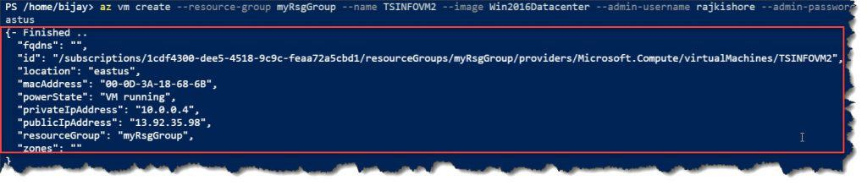

Once You will execute the above command, you will get the output like below

{- Finished ..

"fqdns": "",

"id": "/subscriptions/1cdf4300-dee5-4518-9c9c-feaa72a5cbd1/resourceGroups/myRsgGroup/providers/Microsoft.Compute/virtualMachines/TSINFOVM2",

"location": "eastus",

"macAddress": "00-0D-3A-18-68-6B",

"powerState": "VM running",

"privateIpAddress": "10.0.0.4",

"publicIpAddress": "13.92.35.98",

"resourceGroup": "myRsgGroup",

"zones": ""

}

Now, if you will verify on the Azure Portal, you can able to see the VM created successfully.

